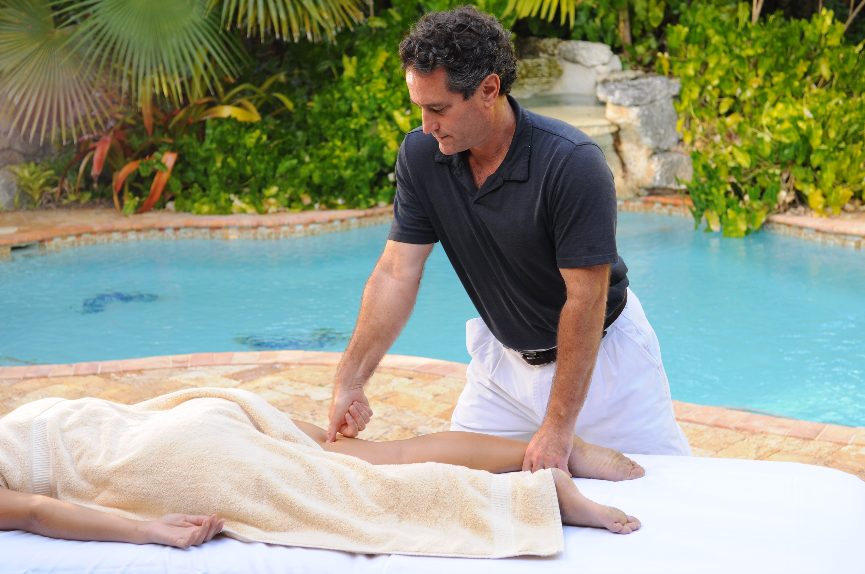
The Ten Traits of a Born Therapist

a short self-checklist for those considering a career in massage therapy
The Ten Traits of a Born Therapist

- Do people swoon and tell you that you have “great hands” when you simply place them upon their neck and shoulders and squeeze a little? Yes £ No £
- Do you feel sympathetic pain someplace in your own body when someone else tells you about their own pain? Yes £ No £
- Do you feel very comfortable with your own and others’ bodies? Are you free from excess inhibition and body-image hang-ups? Yes £ No £
- Do you have the ability and desire to work several hours a day at a very physical endeavor requiring significant stamina? Yes £ No £
- Is it easy for you to remain in silence for an entire hour (or several hours in a row), without indulging in conversation if a client doesn’t wish it? Yes £ No £
- Have people ever told you that your presence makes them feel peaceful or calm?
Yes £ No £
- Do you take your own health seriously by exercising, watching what you eat, and using moderation? Yes £ No £
- Does the idea of changing your lifestyle and livelihood seem exciting rather than horrible? Yes £ No £
- Is the human body a source of wonder and intrigue for you, making you want to learn more about how it works through intensive study? Yes £ No £
- Are you willing to invest a significant amount of time and money for schooling, supplies, association memberships, and equipment? Yes £ No £

If you answered “Yes” to ____ questions . . . then . . .

9-10 | Head to the nearest massage school to enroll.
6-8 | Begin serious investigation about the possibilities; send away for more information from massage schools.
3-5 | Seek the advice and inspiration of established therapists in your area who may be able to give you some insight about what daily life in the massage field is really like.
0-2 | Consider more deeply what your needs and motivations are for looking into massage as a career.

